The use case scenarios for the BPMN

BPMN 1

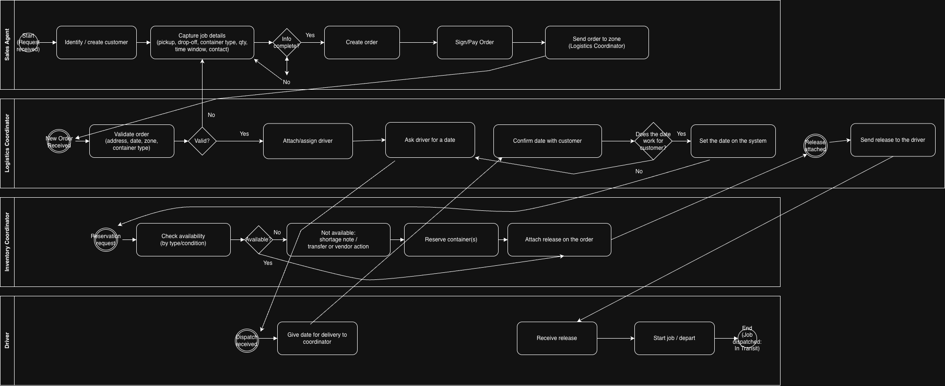

UC-01 Create Delivery Order
- Primary actor: Sales Agent
- Supporting actors: Customer
- Goal: Create a complete delivery order and send it to the correct zone.
- Trigger: Customer requests a container delivery.
- Preconditions: Sales Agent is logged in; customer exists or can be created.
- Postconditions: Order is created; order is sent to the Logistics Coordinator (zone).

Main flow

1.Sales Agent starts a new request.
2.Sales Agent creates a new customer.
3.Sales Agent enters order details: pickup, drop-off, container type, quantity, time window, contact.
4.System validates required fields.
5.Sales Agent creates the order.
6.Customer signs and/or pays.
7.System sends the order to the zone (Logistics Coordinator).
Alternate flows

A1: Missing/invalid job info → system blocks creation and highlights missing fields → Sales Agent fixes → return to step 3.

UC-02 Validate Order in Zone
- Primary actor: Logistics Coordinator
- Supporting actors: Sales Agent
- Goal: Confirm the order is correct for the zone and can be processed.
- Trigger: New order arrives in the zone queue.
- Preconditions: Order exists and is visible to the zone coordinator.
- Postconditions: Order is marked valid and ready for planning, or returned for correction.
Main flow
- Logistics Coordinator opens new order.
- Reviews and validates: address, date request, zone, container type.
Alternate flows
- A1: Order is not valid (wrong zone / missing data / wrong container type) → coordinator returns it for correction → Sales Agent updates details → order is re-sent to zone → restart step 1.

UC-03 Assign Driver and Schedule Delivery Date
- Primary actor: Logistics Coordinator
- Supporting actors: Driver, Customer
- Goal: Assign a driver and agree on a delivery date that works for the customer.
- Trigger: Order is validated and ready to plan.
- Preconditions: Order is valid; drivers exist in the zone.
- Postconditions: Driver assigned; delivery date set in the system.
Main flow
- Logistics Coordinator attaches/assigns a driver to the order.
- Logistics Coordinator asks the driver for an available delivery date.
- Driver provides a delivery date.
- Logistics Coordinator confirms the date with the customer.
- If customer accepts, Logistics Coordinator sets the date in the system.
Alternate flows
- A1: Customer rejects proposed date → coordinator asks driver for another date → repeat steps 2–5.

UC-04 Reserve Containers and Attach Release
- Primary actor: Inventory Coordinator
- Supporting actors: Logistics Coordinator, Inventory Manager (optional)
- Goal: Reserve the required container(s) and attach the release document to the order.
- Trigger: Reservation request received from Logistics Coordinator.
- Preconditions: Order exists; container inventory is maintained per zone.
- Postconditions: Containers reserved (or shortage recorded); release attached to order.
Main flow
- Inventory Coordinator receives reservation request.
- Checks availability by container type and condition.
- Reserves the required container(s).
- Attaches the release document to the order.
- System notifies Logistics Coordinator that the release is attached.
Alternate flows
- A1: Not available → inventory coordinator records shortage and starts transfer/vendor action → once available, reserves container(s) → continue step 4.
- A2: Container damaged/invalid condition → mark as unusable and select another container → continue step 3.

UC-05 Send Release to Driver and Dispatch order
- Primary actor: Logistics Coordinator
- Supporting actors: Driver
- Goal: Send the release to the driver so the job can start.
- Trigger: System shows “Release attached” on the order.
- Preconditions: Delivery date is set; driver is assigned; release is attached.
- Postconditions: Driver has release; job status becomes “In Transit” when driver departs.
Main flow
- Logistics Coordinator receives notification that release is attached.
- Logistics Coordinator sends the release to the driver.
- Driver receives the release.
- Driver starts the job / departs.
- System updates job status to “In Transit” (job dispatched).
Alternate flows
- A1: Release missing/incorrect → coordinator requests inventory correction → wait until “Release attached” again → restart step 1.
- A2: Driver does not acknowledge receipt → coordinator re-sends or escalates→ job remains not dispatched.

